Queries to create tables

CREATE TABLE userinfo

(user_id INT PRIMARY KEY,

first_name VARCHAR (50) NOT NULL,

last_name VARCHAR (50) NOT NULL,

email VARCHAR (320),

contact VARCHAR(50),

gender VARCHAR(10) NOT NULL,

age INT NOT NULL,

birthdate DATE NOT NULL,

lastlogin TIMESTAMP NOT NULL,

registration_date DATE NOT NULL);

CREATE TABLE geographic

(City_id INT PRIMARY KEY,

City_name VARCHAR(50) NOT NULL,

State VARCHAR(50) NOT NULL,

Country VARCHAR(50),

Latitude DECIMAL (9,4) NOT NULL,

Longitude DECIMAL (9,4) NOT NULL,

Delivery_zone VARCHAR(100));

CREATE TABLE restaurant

(restaurant_id INT PRIMARY KEY,

city_id INT NOT NULL,

restaurant_name VARCHAR(100) NOT NULL,

cuisine_type VARCHAR(50) NOT NULL,

address VARCHAR(300),

average_rating DECIMAL(3,1) NOT NULL,

opening_hours VARCHAR(100),

delivery_time TIME NOT NULL,

FOREIGN KEY (city_id) REFERENCES geographic (city_id));

CREATE TABLE orderinfo

(order_id INT PRIMARY KEY,

user_id INT NOT NULL,

restaurant_id INT NOT NULL,

address VARCHAR(300),

order_status varchar(50),

FOREIGN KEY (user_id) REFERENCES userinfo(user_id),

FOREIGN KEY (restaurant_id) REFERENCES restaurant(restaurant_id));

DROP TABLE IF EXISTS payment;

CREATE TABLE payment

(transaction_id INT PRIMARY KEY,

order_id INT NOT NULL,

payment_datetime TIMESTAMP NOT NULL,

amount NUMERIC(10,2) NOT NULL,

method VARCHAR(50) NOT NULL,

transaction_status VARCHAR(50) NOT NULL,

FOREIGN KEY (order_id) REFERENCES orderinfo(order_id));

Queries to copy tables

COPY userinfo(user_id, first_name, last_name, email, contact, gender,

age, birthdate, lastlogin, registration_date)

FROM 'D:\improve\1 courses\sql\archive\Zomato_db\userinfo.csv'

DELIMITER ','

CSV HEADER;

COPY geographic( City_id, City_name, State, Country, Latitude, Longitude, Delivery_zone)

FROM 'D:\improve\1 courses\sql\archive\Zomato_db\geographic.csv'

DELIMITER ','

CSV HEADER;

COPY restaurant (restaurant_id, city_id, restaurant_name,

cuisine_type, address, average_rating, opening_hours, delivery_time)

FROM 'D:\improve\1 courses\sql\archive\Zomato_db\restaurant.csv'

DELIMITER ','

CSV HEADER;

COPY orderinfo(order_id, user_id, restaurant_id, address, order_status)

FROM 'D:\improve\1 courses\sql\archive\Zomato_db\orderinfo.csv'

DELIMITER ','

CSV HEADER;

COPY payment (transaction_id, order_id, payment_datetime, amount, method, transaction_status)

FROM 'D:\improve\1 courses\sql\archive\Zomato_db\payment.csv'

DELIMITER ','

CSV HEADER;

Queries to see tables with data

SELECT * FROM userinfo;

SELECT * FROM orderinfo;

SELECT * FROM restaurant;

SELECT * FROM payment;  
  
  
Queries to Answer Questions

SELECT * FROM geographic;  
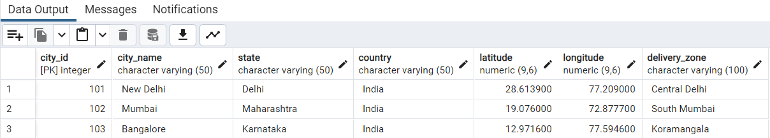  
  
ALTER TABLE geographic

ALTER COLUMN latitude TYPE NUMERIC (6,4),

ALTER COLUMN longitude TYPE NUMERIC(6,4);

SELECT * FROM geographic;

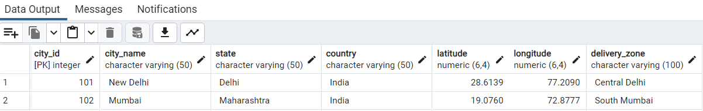  
  
  
-- Que 1 Retrieve the total number of users registered on Zomato.

SELECT count(u.user_id) AS totalusers FROM userinfo u;

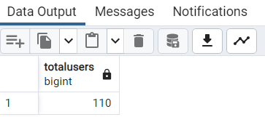

-- Que 2 list of users who have placed orders using the 'cash' payment method.

SELECT u.user_id, u.first_name, u.last_name

FROM userinfo u

JOIN orderinfo o ON u.user_id = o.user_id

JOIN payment p ON o.order_id = p.order_id

WHERE TRIM(LOWER(p.method)) = 'cash'; -- trim and lower is used to convert

--cash into lower case and remove leading or trailing spaces

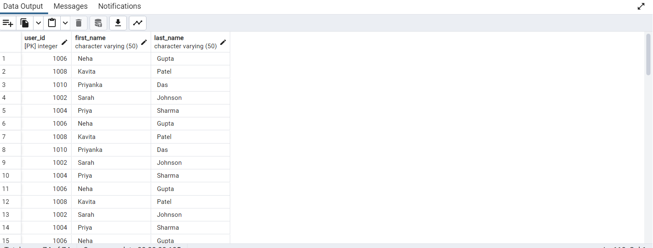

-- Que 3 Find the number of restaurants in each city.

SELECT g.city_name, COUNT(DISTINCT r.restaurant_id) AS restaurant_count

FROM geographic g

LEFT JOIN restaurant r ON g.City_id = r.city_id

GROUP BY g.city_name

ORDER BY restaurant_count DESC;

-- Que 4 List all the unique cuisine types available on Zomato.

SELECT DISTINCT r.cuisine_type FROM restaurant r;

-- Que 5 find total no of cuisine types available on Zomato.

SELECT COUNT(DISTINCT cuisine_type) AS total_cuisine_types

FROM restaurant;

-- Que 6 Retrieve the top-rated restaurant in each city.

SELECT r.restaurant_id, r.restaurant_name,cuisine_type, average_rating FROM restaurant r

ORDER BY average_rating DESC;

----- OR-----------------------------------

WITH RankedRestaurants AS (

SELECT

r.restaurant_id,

r.restaurant_name,

r.cuisine_type,

r.average_rating,

g.City_name,

ROW_NUMBER() OVER (PARTITION BY g.City_name ORDER BY r.average_rating DESC) AS rn

FROM

restaurant r

JOIN geographic g ON r.city_id = g.City_id

)

SELECT

restaurant_id,

restaurant_name,

cuisine_type,

average_rating,

City_name

FROM

RankedRestaurants

WHERE rn = 1

ORDER BY average_rating DESC;

-------------------------------------------------------OR----------------------------------------

WITH RankedRestaurants AS (

SELECT

r.restaurant_id,

r.restaurant_name,

r.cuisine_type,

r.average_rating,

g.City_name,

ROW_NUMBER() OVER (PARTITION BY g.City_name ORDER BY CAST(r.average_rating AS DECIMAL(3, 1)) DESC) AS rn

FROM

restaurant r

JOIN geographic g ON r.city_id = g.City_id

)

SELECT

restaurant_id,

restaurant_name,

cuisine_type,

average_rating,

City_name

FROM

RankedRestaurants

WHERE rn = 1

ORDER BY average_rating DESC;

------------------------------OR------------------------------------------------------

SELECT r.restaurant_id, r.restaurant_name, r.cuisine_type, r.average_rating, g.City_name

FROM restaurant r

JOIN (

SELECT city_id, MAX(average_rating) AS max_rating

FROM restaurant

GROUP BY city_id

) max_ratings

ON r.city_id = max_ratings.city_id AND r.average_rating = max_ratings.max_rating

JOIN geographic g ON r.city_id = g.City_id

ORDER BY r.average_rating DESC;

-------------------------------OR---------------------------------------------

SELECT r.restaurant_id, r.restaurant_name, r.cuisine_type, r.average_rating, g.City_name

FROM restaurant r

JOIN geographic g ON r.city_id = g.City_id

ORDER BY r.average_rating DESC;

------------------------------------OR-------------------------------------------

WITH RankedRestaurants AS (

SELECT

r.restaurant_id,

r.restaurant_name,

r.cuisine_type,

r.average_rating,

g.City_name,

ROW_NUMBER() OVER (PARTITION BY g.City_name ORDER BY r.average_rating DESC) AS rn

FROM

restaurant r

JOIN geographic g ON r.city_id = g.City_id

)

SELECT

restaurant_id,

restaurant_name,

cuisine_type,

average_rating,

City_name

FROM

RankedRestaurants

WHERE rn = 1

ORDER BY average_rating DESC;-- Sort by average_rating

-------------------------------------or--------------------------------------------------

WITH RankedRestaurants AS (

SELECT

r.restaurant_id,

r.restaurant_name,

r.cuisine_type,

r.average_rating,

g.City_name,

ROW_NUMBER() OVER (PARTITION BY g.City_name ORDER BY r.average_rating DESC) AS rn

FROM

restaurant r

JOIN geographic g ON r.city_id = g.City_id

)

SELECT

restaurant_id,

restaurant_name,

cuisine_type,

average_rating,

City_name

FROM

RankedRestaurants

WHERE rn = 1

ORDER BY average_rating DESC; -- Sort by average_rating

-- Que 7 Find the average delivery time for restaurants in each city.

SELECT g.city_name, AVG(r.delivery_time) AS avg_delivery_time

FROM restaurant r

JOIN geographic g ON r.city_id = g.city_id

GROUP BY city_name

ORDER BY avg_delivery_time DESC

----------------------------------------------------------OR------------------------

SELECT g.City_name, ---BETTER WAY TO SOLVE THE QUESTION

AVG(EXTRACT(EPOCH FROM r.delivery_time)::INT) AS average_delivery_time_seconds --To extract the delivery time in seconds

FROM restaurant r

JOIN geographic g ON r.city_id = g.City_id

GROUP BY g.City_name

ORDER BY average_delivery_time_seconds DESC;

-- QUE 8 Count the total number of Delivered orders.

SELECT COUNT(*) AS total_completed_orders

FROM orderinfo

WHERE TRIM(LOWER(order_status)) = 'delivered'; --

-- Que 9 List all the users who have not logged in for the last 30 days.

SELECT u.user_id, u.first_name, u.last_name FROM userinfo u

WHERE lastlogin <= NOW()- INTERVAL '30 days'; --- current time - 30 days

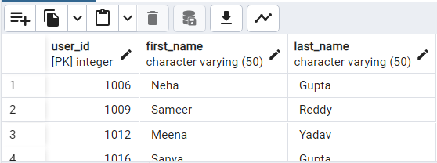

-- Que 10 Find the most common gender among Zomato users.

SELECT TRIM(LOWER(u.gender))AS user_gender, COUNT(u.gender) AS gendertotal FROM userinfo u

GROUP BY user_gender

ORDER BY gendertotal DESC

LIMIT 1;

--------------------------------------or-------------------------------------

SELECT TRIM(LOWER(gender)) AS user_gender, COUNT(*) AS gender_count

FROM userinfo

GROUP BY user_gender

ORDER BY gender_count DESC

LIMIT 1;

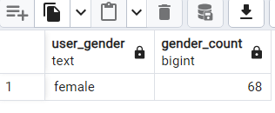

-- QUE 11 Retrieve the restaurants that are currently open (based on current time).

SELECT * FROM restaurant

UPDATE restaurant ----- because opening_hours data was not consistent some places it had extra spaces

SET opening_hours = REPLACE(opening_hours, ' - ', ' - ')

WHERE opening_hours LIKE '% - %'

AND opening_hours NOT LIKE '% - %';

---------------------------------------ANS TO QUE

SELECT restaurant_id, restaurant_name, opening_hours, delivery_time

FROM restaurant

WHERE opening_hours IS NOT NULL

AND delivery_time IS NOT NULL

AND CAST(CURRENT_TIME AS TIME) BETWEEN

CAST(TRIM(BOTH ' ' FROM SUBSTRING(opening_hours, 1, POSITION(' - ' IN opening_hours) - 1)) AS TIME)

AND

CAST(TRIM(BOTH ' ' FROM SUBSTRING(opening_hours, POSITION(' - ' IN opening_hours) + 2)) AS TIME);

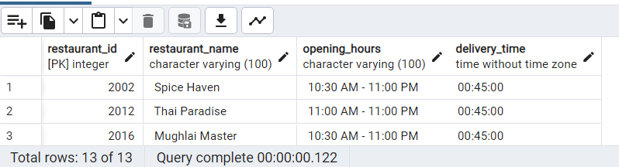

-- Que 12 Calculate the total revenue generated by Zomato.

SELECT SUM(amount) AS total_revenue FROM payment;

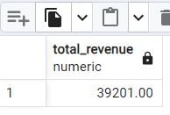

-- Que 13 Find the top 5 users who have placed the most orders.

SELECT u.user_id, u.first_name, u.last_name, COUNT(o.order_id) AS order_count

FROM userinfo u

JOIN orderinfo o ON u.user_id = o.user_id

GROUP BY u.user_id, u.first_name, u.last_name

ORDER BY order_count DESC

LIMIT 5;

----------or--------------

SELECT u.user_id, u.first_name, u.last_name, COUNT(o.user_id) AS total_orders FROM orderinfo o

JOIN userinfo u ON u.user_id = o.user_id

Group BY u.user_id

ORDER BY total_orders DESC

LIMIT 5;

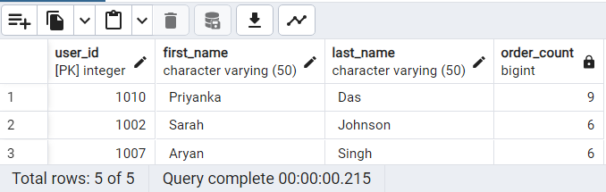

-- Que 14 List the restaurants that offer Indian cuisine and have an average rating above 4.

SELECT r.restaurant_id, r.restaurant_name, r.cuisine_type, r.average_rating

FROM restaurant r

WHERE TRIM(BOTH ' ' FROM LOWER(r.cuisine_type)) = 'indian'

AND average_rating > 4;

--BOTH keyword removes all leading and trailing spaces as well as any spaces within the text itself.

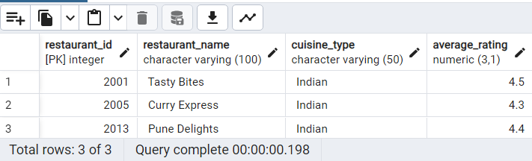

-- Que 15 List the restaurants that offer North Indian cuisine

SELECT r.restaurant_id, r.restaurant_name, r.cuisine_type, r.average_rating

FROM restaurant r

WHERE TRIM(BOTH ' ' FROM LOWER(r.cuisine_type)) = 'north indian';

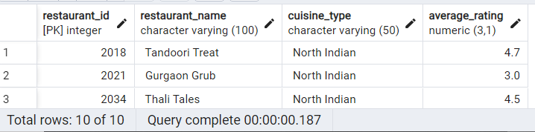

-- Que 16 List the restaurants that offer North Indian cuisine and have an average rating above 4.

SELECT r.restaurant_id, r.restaurant_name, r.cuisine_type, r.average_rating

FROM restaurant r

WHERE TRIM(BOTH ' ' FROM LOWER(r.cuisine_type)) = 'north indian'

AND average_rating > 4;

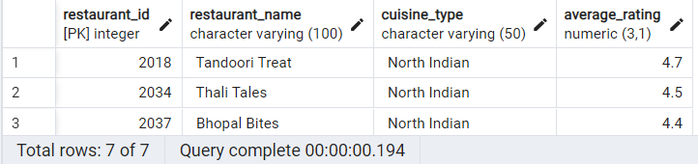

-- Que 17 Calculate the total revenue generated by each payment method.

UPDATE payment

SET method = TRIM(LOWER(method)); -- method column data was not standardized

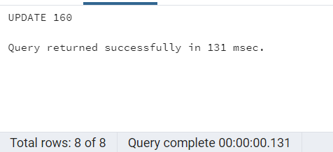

SELECT p.method, SUM(p.amount) AS total_revenue FROM payment p

GROUP BY p.method;

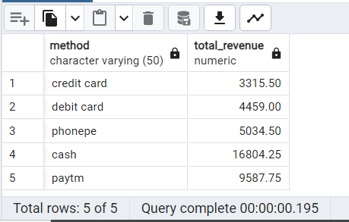

-- Que 18 Identify the user who has placed the largest order by amount.

SELECT u.user_id, u.first_name, u.last_name, MAX(p.amount) AS largest_order_amount

FROM userinfo u

JOIN orderinfo o ON u.user_id = o.user_id

JOIN payment p ON o.order_id = p.order_id

GROUP BY u.user_id, u.first_name, u.last_name

ORDER BY largest_order_amount DESC

LIMIT 1;

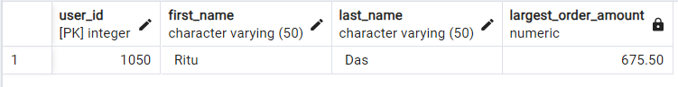

------------------------OR--------

SELECT u.user_id, u.first_name, u.last_name, MAX(p.amount) AS largest_order_amount

FROM payment p

JOIN orderinfo o ON o.order_id = p.order_id

Join userinfo u ON u.user_id = o.user_id

GROUP BY u.user_id

ORDER BY largest_order_amount DESC

LIMIT 1;

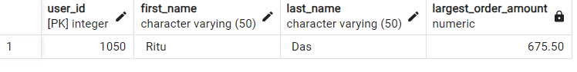

-- Que 19 find top 5 users who spent highest on zomato

SELECT u.user_id, u.first_name, u.last_name, SUM(p.amount) AS total_amount,

COUNT(o.user_id) AS total_orders FROM payment p

JOIN orderinfo o ON o.order_id = p.order_id

Join userinfo u ON u.user_id = o.user_id

GROUP BY u.user_id

ORDER BY total_amount DESC

LIMIT 5;

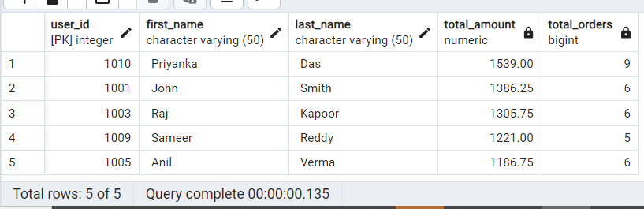

-------OR--------------------------------

SELECT u.user_id, u.first_name, u.last_name, SUM(p.amount) AS total_spending

FROM userinfo u

JOIN orderinfo o ON u.user_id = o.user_id

JOIN payment p ON o.order_id = p.order_id

GROUP BY u.user_id, u.first_name, u.last_name

ORDER BY total_spending DESC

LIMIT 5;

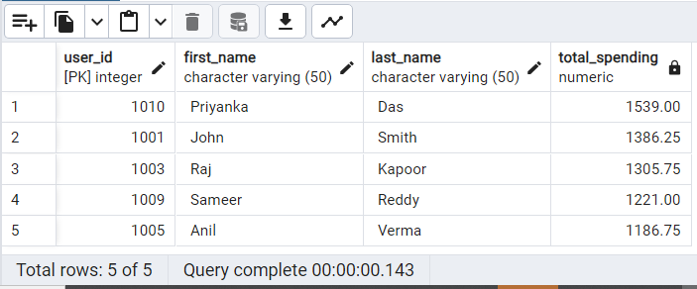

-- QUE 20 Find the city with the highest number of restaurants offering seafood cuisine.

SELECT g.city_name, COUNT(r.restaurant_id) AS seafood_restaurant_count

FROM geographic g

JOIN restaurant r ON r.city_id = g.city_id

WHERE TRIM(BOTH ' ' FROM LOWER (r.cuisine_type)) = 'seafood'

GROUP BY g.city_name

ORDER BY seafood_restaurant_count DESC;

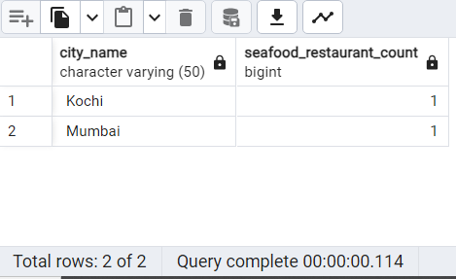

------------------------or----------------------------------

SELECT g.City_name, COUNT(r.restaurant_id) AS seafood_restaurant_count

FROM geographic g

LEFT JOIN restaurant r ON g.City_id = r.city_id

WHERE TRIM(BOTH ' ' FROM LOWER (r.cuisine_type)) LIKE '%seafood%'

GROUP BY g.City_name

ORDER BY seafood_restaurant_count DESC;

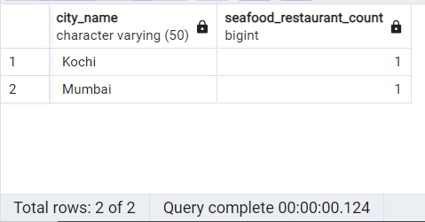

--Que 21 Calculate the average age of Zomato users.

SELECT AVG(u.age) AS average_age FROM userinfo u

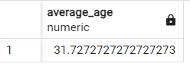

----------or--------------------------------------

SELECT ROUND(AVG(u.age),2) AS average_age FROM userinfo u

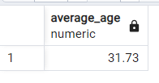

-- QUE 22 List the cities with the highest and lowest average delivery times.

SELECT g.City_name, AVG(EXTRACT(EPOCH FROM delivery_time)) AS average_delivery_time_seconds

FROM geographic g

LEFT JOIN restaurant r ON g.City_id = r.city_id

WHERE r.delivery_time IS NOT NULL

GROUP BY g.City_name

ORDER BY average_delivery_time_seconds DESC

LIMIT 1;

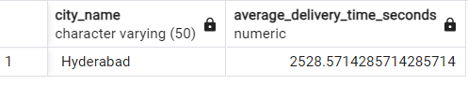

SELECT g.City_name, AVG(EXTRACT(EPOCH FROM delivery_time)) AS average_delivery_time_seconds

FROM geographic g

LEFT JOIN restaurant r ON g.City_id = r.city_id

WHERE r.delivery_time IS NOT NULL

GROUP BY g.City_name

ORDER BY average_delivery_time_seconds ASC

LIMIT 1;

